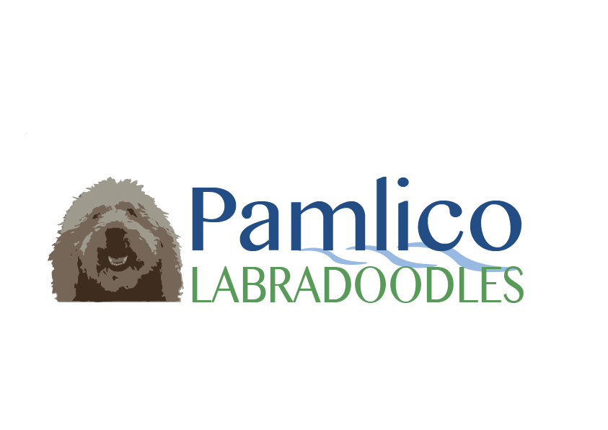

SPAY/NEUTER CONTRACT

Breed Multigenerational Australian Labradoodle_______________________

Date Whelped _________ Sex________ Color _____________________

Sire _________________________

Dam_________________________

Breeder Ed and Tonna Watson______________________________________

New Owner ________________________Date Purchased________________

Price Paid ________________

Spay/Neuter ­­­­­­______________

Permanent ownership of this dog is contingent upon your compliance with this agreement. Proof of the spay/neuter must be received by ***Pamlico Labradoodles*** within fourteen (14) days after the surgery. In the event that the dog’s health does not allow this agreement to be honored, ***Pamlico Labradoodles*** must be provided with a statement from your veterinarian that this dog is not yet in physical or emotional condition for surgery. Based upon the veterinarian’s evaluation of this dog the (purchaser) will contact the veterinarian and establish the earliest date that the procedure can be performed. (Purchaser) will notify the breeder of this amendment in writing, at which time all other conditions of this agreement will apply and be enforced.

This is the responsibility of the PURCHASER, not the veterinarian, to ensure that ***Pamlico Labradoodles*** has received verification that the surgery has been performed. A copy of the medical record as well as the receipt is necessary verification along with the veterinarian’s phone number to follow up about procedure. Failure to comply with this agreement by the date below, unless otherwise agreed to in writing will be considered a breach of the Contract and PURCHASER will transport this dog back to ***Pamlico Labradoodles*** and will not be entitled to a refund.

By my signature below, I agree to have this dog spayed/neutered by the age of **ONE YEAR**

**(12 MONTHS)** and I understand that this spay/neuter agreement is an agreement that this dog will not produce a litter of puppies either as purposely bred or by accidental breeding.

I understand that paperwork for CKC registration of this puppy will be released to me upon ***Pamlico Labradoodles’*** receipt of proof of spay/neuter of said puppy.

I also agree that should puppy not be SPAYED/NEUTERED that I will return said puppy back to the seller/breeder with no refund.

Purchaser’s Name (please print):__________________________________­­­_______________

Purchaser’s Signature____________________________________________________________________

Date:________________________________________________________________________

Address____________________________________________________City_______________

State __________ Zip _____________

Telephone Number _________________________________________________

Breeder’s Signature_____________________________________________________________________

Address: City: Washington­_

State: NC Zip: 27889